Saturday, August 29, 2026
9:00 AM - 1:00 PM
The BBOP Center
599 N. Arrowhead Ave San Bernardino, CA 92405

FREE LEGAL CLINIC
Expungements Record Sealing
SB 731 Petition-Based Criminal Defense Family Reunification Family Law

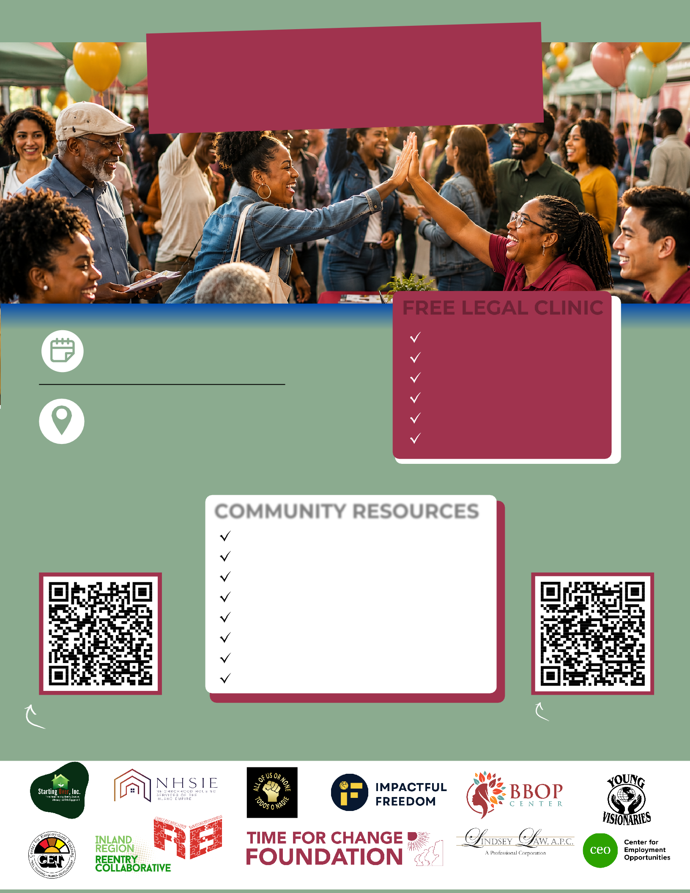
VENDORS WANTED!
EMPOWERMENT AND
ACTION FAIR

Scan to register as a vendor!

COMMUNITY RESOURCES
Housing
Employment Opportunities Education & Training Health & Wellness Services
Mental Health & Recovery Support Kids Fun Zone
Food Raffles

For More Informtion, Call: (909) 886-2994
Register
FOR LEGAL CLINIC

Scan to Register!
Space is limited for legal consultations.

